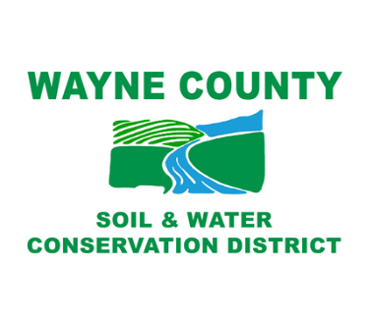
TO: Wayne County Soil & Water Conservation District
7312 Route 31
Lyons, New York 14489

I HEREBY REQUEST COPIES OF THE FOLLOWING RECORD(S):
____________________________________________________________________________________________________________________________________________________________________________________________________________________________________________________________________________________________________________________________________________________

___________________________________________ _______________________________________
Signature Title of Agency (if any) ___________________________________________ _______________________________________
Name (Please print) Phone Number ___________________________________________ _______________________________________
Mailing Address Email Address

___________________________________________ _______________________________________
Date
------------------------------------------------------------------------------------------------------------------------------------------
RECORDS ACCESS OFFICER
_________ APPROVED
_________ DENIED (for the reason(s) checked below)

_______ Confidential Disclosure
_______ Part of Investigatory Files
_______ Unwarranted Invasion of Personal Privacy
_______ Record of Which this Agency is Legal Custodian
_______ Cannot be Found Record is not Maintained by this Agency
_______ Exempted by Statute Other than the Freedom of Information Act
_______ Other (specify) __________________________________________________________

_____________________________ ______________________________ ___________________
Signature Title Date

PLEASE ADDRESS ALL FOIL REQUESTS TO:
Wayne County Soil & Water Conservation District
7312 Route 31, Lyons, New York 14489
Attn: Ron Thorn, District Manager
(315) 946-7200 ext. 1
Ron@WayneNYSWCD.org

